Pointwise Mutual Information
Kenneth W. Church and Patrick Hanks. Word association norms, mutual information, and lexicography. 1990.pdf

1. What is "mutual information?" According to Fano (1961), if two points (words), x and y, have probabilities P(x) and P(y), then their mutual information, I(x,y), is defined to be
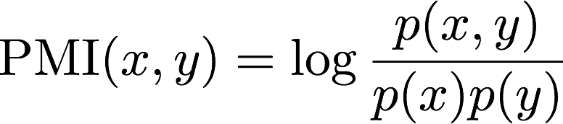
Informally, mutual information compares the probability of observing x and y together (the joint probability) with the probabilities of observing x and y independently (chance). If there is a genuine association between x and y, then the joint probability P(x,y) will be much larger than chance P(x)*P(y), and consequently I(x,y) >>0. If there is no interesting relationship between x and y, then P(x,y)=P(x)*P(y), and thus, I(x,y) ~ O. If x and y are in complementary distribution (meaning if x occurs, y should not be observed), then P(x,y) will be much less than P(x)*P(y), forcing I(x,y) <<0.

2. Understand the dependence between P(x,y) (probability of two events occuring) and P(x)*P(y) (probability of two events occuring, when they are independent).
https://people.richland.edu/james/lecture/m170/ch05-rul.html

P(x,y) = P(x)*P(y), only when events x and y are completely independent.
Two events are independent if the occurrence of one does not change the probability of the other occurring.
For ex. P(x)=0.2, and P(y)=0.6. If the events are independent (ex. consequent coin flips), the joint probability of independent events: P(x,y) = P(x)*P(y) = 0.2*0.6=0.12

Dependent Events
If the occurrence of one event does affect the probability of the other occurring, then the events are dependent.

Conditional Probability
The probability of event B occurring that event A has already occurred is read "the probability of B given A" and is written: P(B|A)
For ex.: P(A) = 0.20, P(B) = 0.70, P(B|A) = 0.40
P(B) on it's own is quite high 0.7, but probability of P(B|A) = 0.40 is lower. This indicates that the possibility of event B occuring is lowered, in case we know that event A has occured.
When events are dependent, probability of both x and y occuring: P(x,y) = P(x)*P(y|x);

Thus, for PMI: . This shows that if y and x are completely independent (seeing these particular two words in one sentence is completely random), than . Else, if observing word x increases chances of seeing word y, it will be >> 1

Some more examples: http://sites.nicholas.duke.edu/statsreview/probability/jmc/

Joint probability: p(A and B). The probability of event A and event B occurring. It is the probability of the intersection of two or more events. The probability of the intersection of A and B may be written p(A ∩ B). Example: the probability that a card is a four and red =p(four and red) = 2/52=1/26. (There are two red fours in a deck of 52, the 4 of hearts and the 4 of diamonds).
Conditional probability: p(A|B) is the probability of event A occurring, given that event B occurs. Example: given that you drew a red card, what’s the probability that it’s a four (p(four|red))=2/26 =1/13. So out of the 26 red cards (given a red card), there are two fours so 2/26=1/13.

3. To understand how Log2 affects the PMI probability score, see log2 chart (and log10):

